For anyone working or travelling over this holiday weekend, please stay safe!

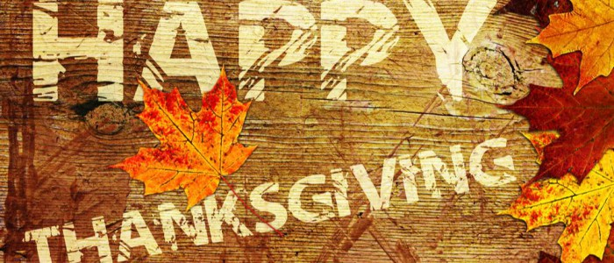

FROM THE OFFICERS, MEMBERS AND STAFF OF I.B.E.W. LOCAL UNION 254